**ENGN2020 – Midterm #2**

### Problem 1

#### Class Vertex:

Here is a brief description of Class Vertex, as shown in Table. 1.

**Table.1** The data members and methods of the Class Vertex

|  |  |  |
| --- | --- | --- |
|  | Name | Description |
| Data member | board | Store the current tic-tac-toe board |
| Method | __init__ | The constructor of the class, takes in the board stored in a 3x3 matrix |
| ﻿isFull | Check whether is board is full |
| ﻿get_empty | ﻿get all empty positions on the board |

**Please see the code attached in Appendix 1.1.**

#### Method of get_status():

The method get_status() is added to the Vertex class. The brief description of get_status() is shown in Table.2.

**Table.2** The description of method get_status()

|  |  |  |  |
| --- | --- | --- | --- |
| Name | get_status | | |
| Description | ﻿check the result of the current board | | |
|  | Name | Type | Description |
| Input | self | object | The object itself |
| Output | ﻿result | string | The result from 'X wins' , 'O wins' and 'in progress' |

In the method get_status(), several steps are used:

Step 1: Check all rows to see if all elements are equal. If so, check if it`s 1, -1 or 0.

Step 2: Check all columns to see if all elements are equal. If so, check if it`s 1, -1 or 0.

Step 3: Check the diagonal line from left top to right bottom to see if all elements are equal. If so, check if it`s 1, -1 or 0.

Step 4: Check the diagonal line from right top to left bottom to see if all elements are equal. If so, check if it`s 1, -1 or 0.

**Please see the code attached in Appendix 1.1.**

#### Function of computer_move

The brief description of computer_move () is shown in Table.3.

**Table.3** The description of function computer_move ()

|  |  |  |  |
| --- | --- | --- | --- |
| Name | computer_move | | |
| Description | Decide the computer`s next move purely based on brute-force probabilites | | |
|  | Name | Type | Description |
| Input | ﻿currentBoard | Vertex | ﻿the object of Class Vertex storing the current board |
| ﻿myTurn | string | ﻿the input indicate whose turn it is('X' or 'O') |
| Output | ﻿﻿newBoard | Vertex | ﻿the object of Class Vertex after the move |

A helper function called ﻿calculate_probability() is used in computer_move to calculate the winning probability of all possible moves. The brief description of ﻿calculate_probability() is shown is Table.4.

**Table.4** The description of function calculate_probability ()

|  |  |  |  |
| --- | --- | --- | --- |
| Name | calculate_probability | | |
| Description | ﻿calculate the win probability of all possible moves using DFS method | | |
|  | Name | Type | Description |
| Input | ﻿currentBoard | Vertex | ﻿the object of Class Vertex storing the current board |
| ﻿myTurn | string | ﻿the input indicate whose turn it is('X' or 'O') |
| Output | ﻿﻿result | dict | ﻿﻿the total outcome and win times of each possible move |

Test results of the computer_move() function:

1. Case 1:

Code:

﻿A = np.array([[ 0, 0,-1],

[ 0, 1, 1],

[ 1, 0,-1]])

a = Vertex(A)

nextMove = computer_move(a,'O')

print(nextMove.board)

Result:

The board after computer`s move is:

﻿ [[-1 0 -1]

[ 0 1 1]

[ 1 0 -1]]

The next move of computer is on the top left of the board.

﻿ The total number of possible outcomes is 5

﻿ The total number of possible winning outcomes is 1

1. Case 2:

Result:

The board after computer`s move is:

﻿ ﻿[[ 0 0 -1]

[ 0 1 0]

[ 0 0 0]]

The next move of computer is in the center of the board.

﻿ The total number of possible outcomes is ﻿3468

﻿ The total number of possible winning outcomes is ﻿1312

1. Case 3:

Result:

The board after computer`s move is:

﻿ ﻿ [[ 1 0 0]

[-1 -1 0]

[ 1 -1 1]]

The next move of computer is in the center of the board.

﻿ The total number of possible outcomes is 6

﻿ The total number of possible winning outcomes is ﻿4

1. Case 4:

Result:

The board after computer`s move is:

﻿ ﻿[[ 1 0 0]

[ 0 -1 0]

[ 0 0 0]]

The next move of computer is on the top left of the board.

﻿ The total number of possible outcomes is ﻿3198

﻿ The total number of possible winning outcomes is ﻿792

**Please see the code in Appendix 1.2.**

#### The complete tic-tac-toe game

The problem1.py contains the game as well as all necessary modules. Please run the .py file under shell by:

***python #full path of the problem1.py***

If you are already under python environment, please run the .py file by:

***%run*** ***#full path of the problem1.py***

The game is a pure-text game, the interface is shown in Fig.1.

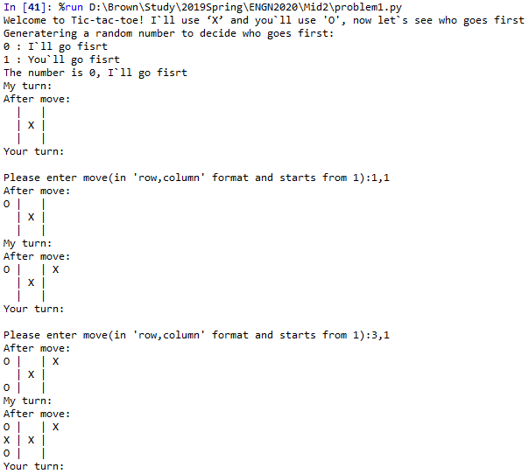

**Fig 1.** The interface of tic-tac-toe game

Please note that the when you enter your move, it should follow the ‘row,column’ format, and row and column starts with 1.

**Please see the complete code in Appendix 1.3.**

### Problem 2

#### Answer:

Solve the function by ﻿scipy.optimize.﻿fsolve()，when the initial values of [CA, T] differs, three different roots can be calculated:

1. When the initial values of [CA, T] = ﻿[10, 300.0], the roots are CA = ﻿1.9052761218083372, T = ﻿301.894930354838.
2. When the initial values of [CA, T] = ﻿[2.0, 500.0], the roots are CA = ﻿0.2527196071917932, T = ﻿334.9539600568946.
3. When the initial values of [CA, T] = ﻿[ ﻿200, ﻿3000], the roots are CA = ﻿0.8066255609579893, T = ﻿323.873193247566.

In conclusion, there are three possible solutions:

$\left\{\begin{matrix}CA=﻿1.90527612180833 \\ T=﻿301.894930354838\end{matrix}\right.$, $\left\{\begin{matrix}CA=﻿0.252719607191793 \\ T=﻿﻿﻿334.9539600568946\end{matrix}\right.$ and $\left\{\begin{matrix}CA=﻿﻿0.80662556095798 \\ T=﻿﻿﻿323.873193247566\end{matrix}\right.$

**Please see the code in Appendix 2.1.**

#### Answer:

Let***x1 , x2,*** stand for ***CA****,* ***T*** and ***Tinlet,*** respectively. Then the given functions can be written as:

$$f_{1}\left(x_{1},x_{2}\right)=\frac{C_{A,inlet}-x_{1}}{τ}-kx_{1}$$

$$f_{2}\left(x_{1},x_{2},θ\right)=\frac{θ-x_{2}}{τ}-\frac{H_{rxn}}{ρc_{p}}kx_{1}$$

$$k=Ae^{-E_{A}/Rx_{2}}$$

Then the Jacobian matrix of the given functions can be written as:

$$J=\left[\begin{matrix}\frac{∂f_{1}}{∂x_{1}} & \frac{∂f_{1}}{∂x_{2}} \\ \frac{∂f_{2}}{∂x_{1}} & \frac{∂f_{2}}{∂x_{2}}\end{matrix}\right]=\left[\begin{matrix}-\frac{1}{τ}-k & -kx_{1}\frac{E_{A}}{Rx_{2}^{2}} \\ -\frac{H_{rxn}}{ρc_{p}}k & -\frac{1}{τ}-kx_{1}\frac{{H_{rxn}E}_{A}}{ρc_{p}Rx_{2}^{2}}\end{matrix}\right]$$

Let dev(J) equals to 0 together with $f_{1}\left(x_{1},x_{2}\right)=0$, we can solve for two roots:

$\left\{\begin{matrix}x_{1}=﻿1.595861231544271 \\ x_{2}=﻿﻿312.0553014597565\end{matrix}\right.$ and $\left\{\begin{matrix}x_{1}=﻿0.4697772609992 \\ x_{2}=﻿﻿﻿329.45193859762\end{matrix}\right.$

Use those two roots and $f_{2}\left(x_{1},x_{2},θ\right)=0$ to solve $θ:$

$$\left\{\begin{matrix}θ_{1}=﻿﻿298.8401691775697 \\ θ_{2}=﻿﻿﻿303.9705942598330\end{matrix}\right.$$

So when $T_{inlet}^{*}=298.8402$ or $T_{inlet}^{*}=303.9706$, where the number of steady-state solutions changes.

**Please see the code in Appendix 2.2.**

#### Answer:

Let***x1 , x2*** stand for ***CA***and***T*** ,respectively.

According to Part(a), there are three solutions:

$\left\{\begin{matrix}x_{1}=﻿1.90527612180833 \\ x_{2}=﻿301.894930354838\end{matrix}\right.$, $\left\{\begin{matrix}x_{1}=﻿0.252719607191793 \\ x_{2}=﻿﻿﻿334.9539600568946\end{matrix}\right.$ and $\left\{\begin{matrix}x_{1}=﻿﻿0.80662556095798 \\ x_{2}=﻿﻿﻿323.873193247566\end{matrix}\right.$

1. $x_{1}=﻿1.90527612180833$ and $x_{2}=﻿301.894930354838$

The Jacobian matrix is:

$$J=\left[\begin{matrix}\frac{∂f_{1}}{∂x_{1}} & \frac{∂f_{1}}{∂x_{2}} \\ \frac{∂f_{2}}{∂x_{1}} & \frac{∂f_{2}}{∂x_{2}}\end{matrix}\right]=\left[\begin{matrix}﻿-0.01749528 & ﻿-0.00026148 \\ ﻿0.01657617 & ﻿-0.01143592\end{matrix}\right]$$

The eigenvalues are $λ_{1}= -0.01666667$ and $λ_{2}= ﻿-0.01226453$

Since all Re($λ$)<0, the state of this solution is stable.

1. $x_{1}=﻿0.252719607191793$ and $x_{2}=﻿334.9539600568946$

The Jacobian matrix is:

$$J=\left[\begin{matrix}\frac{∂f_{1}}{∂x_{1}} & \frac{∂f_{1}}{∂x_{2}} \\ \frac{∂f_{2}}{∂x_{1}} & \frac{∂f_{2}}{∂x_{2}}\end{matrix}\right]=\left[\begin{matrix}﻿﻿-0.13189849 & ﻿﻿-0.00391809 \\ ﻿﻿2.30518719 & ﻿﻿0.06171394\end{matrix}\right]$$

The eigenvalues are $λ_{1}= ﻿-0.05351788$ and $λ_{2}= ﻿﻿-0.01666667$

Since all Re($λ$)<0, the state of this solution is stable.

1. $x_{1}=﻿﻿﻿0.80662556095798$ and $x_{2}=﻿323.873193247566$

The Jacobian matrix is :

$$J=\left[\begin{matrix}\frac{∂f_{1}}{∂x_{1}} & \frac{∂f_{1}}{∂x_{2}} \\ \frac{∂f_{2}}{∂x_{1}} & \frac{∂f_{2}}{∂x_{2}}\end{matrix}\right]=\left[\begin{matrix}﻿﻿﻿-0.04132442 & ﻿﻿﻿-0.00286226 \\ ﻿﻿﻿0.49327293 & ﻿﻿﻿0.04059223\end{matrix}\right]$$

The eigenvalues are $λ_{1}= ﻿﻿-0.01666667$ and $λ_{2}= ﻿﻿﻿0.01593448$

Since any Re($λ$)>0, the state of this solution is unstable.

**Please see the code attached in Appendix 2.3.**

#### Answer:

The ratio of the largest and smallest eigenvalue moduli can be used to judge the stiffness of the differential equations.

According to Part(c), in all three solutions, the ratios of the largest and smallest eigenvalue moduli are rather small.

Therefore, this system of differential equations is not stiff.

From part(c), there is an unstable state. Therefore, from that point of view, the system is not stiff.

#### Answer:

(1) ${CA}_{0}=0, T_{0}=0$

The plot of CA and T versus t is shown in Fig 2.

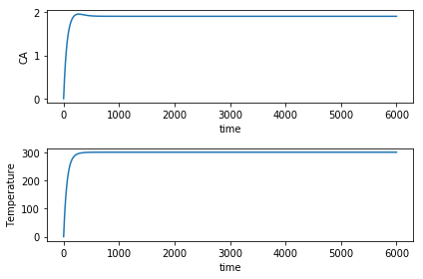

**Fig 2.** The plot of CA and T versus t, when ${CA}_{0}=0, T_{0}=0$

At last, the CA converges to CA = ﻿1.9052761218083372, and T converges to T = ﻿301.894930354838

(2) ${CA}_{0}=0, T_{0}=500$

The plot of CA and T versus t is shown in Fig 3.

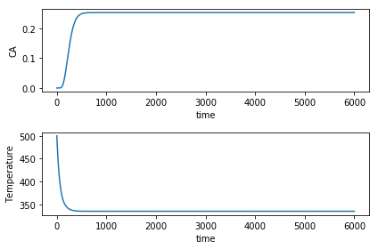

**Fig 3.** The plot of CA and T versus t, when ${CA}_{0}=0, T_{0}=500$

At last, the CA converges to CA = 0.252719607191793, and T converges to T = ﻿334.9539600568946

(3) ${CA}_{0}=10, T_{0}=500$

The plot of CA and T versus t is shown in Fig 4.

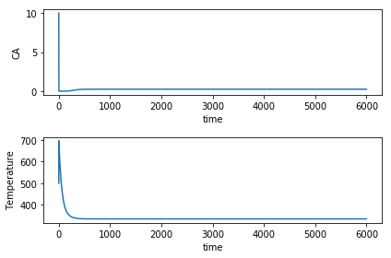

**Fig 4.** The plot of CA and T versus t, when ${CA}_{0}=10, T_{0}=500$

At last, the CA converges to CA = 0.252719607191793, and T converges to T = ﻿334.9539600568946

(4) ${CA}_{0}=2, T_{0}=2500$

The plot of CA and T versus t is shown in Fig 5.

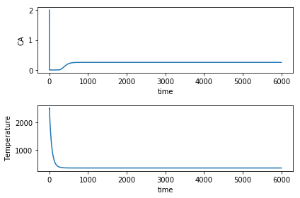

**Fig 5.** The plot of CA and T versus t, when ${CA}_{0}=2, T_{0}=2500$

At last, the CA converges to CA = 0.252719607191793, and T converges to T = ﻿334.9539600568946

(5) ${CA}_{0}=200, T_{0}=0$

The plot of CA and T versus t is shown in Fig 6.



**Fig 6.** The plot of CA and T versus t, when ${CA}_{0}=200, T_{0}=0$

At last, the CA converges to CA = ﻿1.9052761218083372, and T converges to T = ﻿301.894930354838

Basically, when the initial T is relatively high, the system tends to converge to the stable state of:

$$\left\{\begin{matrix}CA=﻿0.252719607191793 \\ T=﻿﻿﻿334.9539600568946\end{matrix}\right.$$

When the initial T is relatively low, the system tends to converge to the stable state of:

$$\left\{\begin{matrix}CA=﻿1.90527612180833 \\ T=﻿301.894930354838\end{matrix}\right.$$

**Please see the attached code in Appendix.2.4.**

#### Answer:

The map that could be used to determine from a given initial condition that which steady state will be reached is shown in Fig.7.

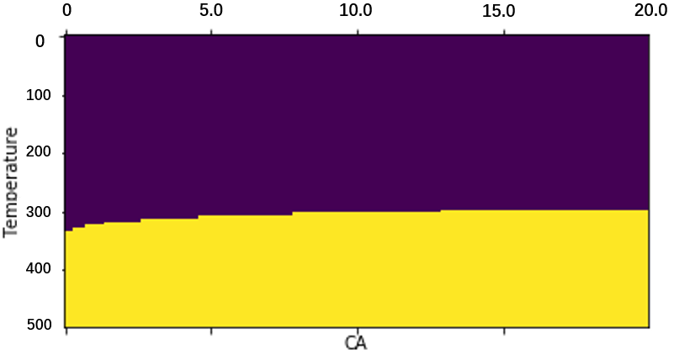

**Fig 7.** The map of steady state based on input initial condition

The purple part indicates the stable state of:

$$\left\{\begin{matrix}CA=﻿1.90527612180833 \\ T=﻿301.894930354838\end{matrix}\right.$$

The yellow part indicates the stable state of:

$$\left\{\begin{matrix}CA=﻿0.252719607191793 \\ T=﻿﻿﻿334.9539600568946\end{matrix}\right.$$

We can draw the similar conclusion with part(e), when the initial T is relatively high, the system tends to converge to the stable state of:

$$\left\{\begin{matrix}CA=﻿0.252719607191793 \\ T=﻿﻿﻿334.9539600568946\end{matrix}\right.$$

When the initial T is relatively low, the system tends to converge to the stable state of:

$$\left\{\begin{matrix}CA=﻿1.90527612180833 \\ T=﻿301.894930354838\end{matrix}\right.$$

**Please see the code attached in Appendix 2.5.**

### Problem 3

#### Answer:

The noise free contour is shown in Fig.8.

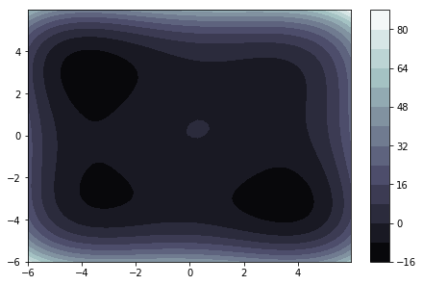

**Fig 8.** The map of steady state based on input initial condition

The contour plots at different of sigma is shown is Fig 9.

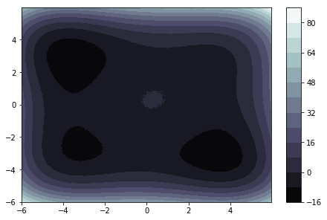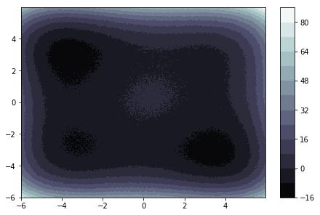

（a） $σ=0.01$（b） $σ=0.1$（c） $σ=1$

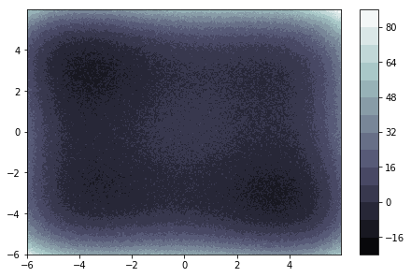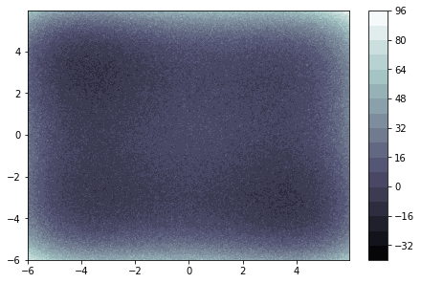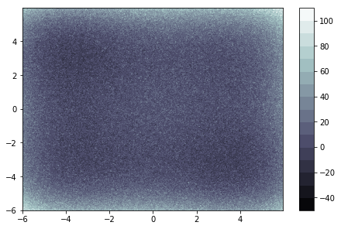

（d） $σ=3$（e） $σ=5$（f） $σ=10$

**Fig 9.** Contour plots at different of sigma

From Fig.9. we can see when $σ$ increases, the influence becomes more and more significant. When $σ=5$, the influence becomes quite significant. When $σ=10$, the noise nearly washes out the signal.

#### Answer:

Given the initial simplex of [(0,0),(-1,0),(0,1)]，the Nelder-Mead algorithm will find the minimum on the noise free function. The process is shown in Fig.10.

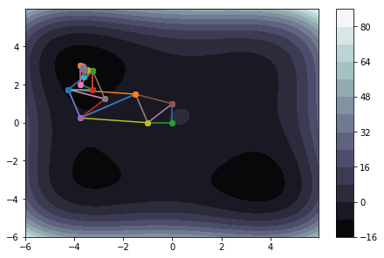

Fig.10. The process that Nelder-Mead algorithm finds the minimum given the initial simplex

The position of the this local minima is (-3.63460063, 2.91071661)

Besides, there are three additional local minimas in the function. By using different initial values, we can find positions of those local minimas:

(-3.25733016, -2.64544543)

(2.98019805, 2.31968217)

(3.43582195, -3.0972582)

The number of times out of 100 that converges to the same local minima and the number of times out of 100 that converges to any local minima based on different $σ$ is shown in Table.5.

**Table.5** The number of converging result

|  |  |  |
| --- | --- | --- |
| Sigma $σ$ | Number of same minima | Number of any minima |
| 0 | 1000 | 1000 |
| 0.5 | 632 | 892 |
| 1 | 204 | 422 |
| 1.5 | 56 | 176 |
| 2 | 32 | 85 |
| 2.5 | 18 | 46 |
| 3 | 1 | 15 |
| 3.5 | 4 | 17 |
| 4 | 3 | 14 |
| 4.5 | 2 | 7 |
| 5 | 1 | 4 |

The plots of those two kinds of number versus sigma is shown in Fig.11.

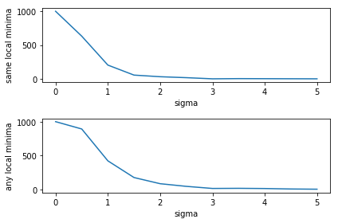

Fig.11. The number of converging to the same local minima and the number of converging to any local minima.

#### Answer:

(1) use Nelder-Mead method in scipy.optimize.minimize

The number of times out of 100 that converges to the same local minima and the number of times out of 100 that converges to any local minima based on different $σ$ is shown in Table.6.

1. **Table.6** The number of converging results

|  |  |  |
| --- | --- | --- |
| Sigma $σ$ | Number of same minima | Number of any minima |
| 0 | 1000 | 1000 |
| 0.5 | 614 | 996 |
| 1 | 326 | 776 |
| 1.5 | 208 | 495 |
| 2 | 109 | 296 |
| 2.5 | 77 | 225 |
| 3 | 40 | 127 |
| 3.5 | 36 | 102 |
| 4 | 19 | 79 |
| 4.5 | 17 | 59 |
| 5 | 15 | 50 |

The plots of those two kinds of number versus sigma is shown in Fig.12.

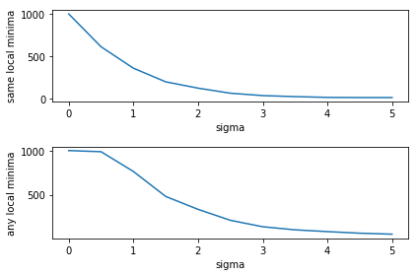

Fig.12. The number of converging to the same local minima and the number of converging to any local minima.

(2) use BFGS method in scipy.optimize.minimize

The number of times out of 100 that converges to the same local minima and the number of times out of 100 that converges to any local minima based on different $σ$ is shown in Table.7.

1. **Table.7** The number of converging results

|  |  |  |
| --- | --- | --- |
| Sigma $σ$ | Number of same minima | Number of any minima |
| 0 | 1000 | 1000 |
| 0.5 | 799 | 799 |
| 1 | 668 | 668 |
| 1.5 | 495 | 495 |
| 2 | 362 | 362 |
| 2.5 | 239 | 239 |
| 3 | 211 | 211 |
| 3.5 | 140 | 140 |
| 4 | 125 | 125 |
| 4.5 | 100 | 100 |
| 5 | 72 | 72 |

The plots of those two kinds of number versus sigma is shown in Fig.13.

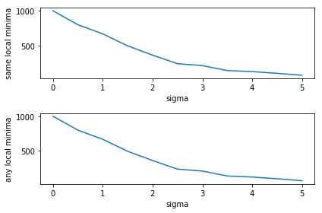

Fig.12. The number of converging to the same local minima and the number of converging to any local minima.

Among the built in Nelder-Mead, home-made Nelder-Mead and BFGS, BFGS is definitely the best algorithm. The speed is extremely fast and the algorithm doesn`t converge to other local minimas. Also, it`s accuracy is better than the other two algorithms with existence of noise.

### Appendix

#### 1. Code of Problem 1

(1) part a and b

class Vertex:

'''

* @name: __init__

* @description: the constructor of the class, save the input board

* @param board: the input board which is saved in a 3X3 matrix

'''

def __init__(self,board):

self.board = board

'''

* @name: get_status

* @description: check the result of the current board

* @return: the result('X wins', 'O wins' or 'in progress')

'''

def get_status(self):

#check all rows

for i in range(3):

#if the current row has three same element

if self.board[i][0] == self.board[i][1] and self.board[i][0] == self.board[i][2]:

if self.board[i][0] == 1:

return "X wins"

if self.board[i][0] == -1:

return "O wins"

#check all cols

for i in range(3):

#if the current col has three same element

if self.board[0][i] == self.board[1][i] and self.board[0][i] == self.board[2][i]:

if self.board[0][i] == 1:

return "X wins"

if self.board[0][i] == -1:

return "O wins"

#check diagonal

if self.board[0][0] == self.board[1][1] and self.board[0][0] == self.board[2][2]:

if self.board[0][0] == 1:

return "X wins"

if self.board[0][0] == -1:

return "O wins"

#check diagonal

if self.board[0][2] == self.board[1][1] and self.board[0][2] == self.board[2][0]:

if self.board[0][2] == 1:

return "X wins"

if self.board[0][2] == -1:

return "O wins"

return 'in progress'

'''

* @name: get_children

* @description: get all possible board with one additional move from the current board

* @return: the result('X wins', 'O wins' or 'in progress')

'''

def get_children(self,index):

#get the current row and col

row = index // 3

col = index % 3

#the 8 neighbors

offsetRow = [-1,-1,-1, 0, 0, 1, 1, 1]

offsetCol = [-1, 0, 1,-1, 1,-1, 0, 1]

#the list to save final results

result = []

for i in range(8):

y = row + offsetRow[i]

x = col + offsetCol[i]

if y>=0 and y<3 and x>=0 and x<3:

if self.board[y][x] == 0:

result.append(3*y+x)

return result

'''

* @name: isFull

* @description: check whether the current board is full

* @return: boolean, whether the current boad is full

'''

def isFull(self):

for row in range(3):

for col in range(3):

if self.board[row][col] == 0:

return False

return True

'''

* @name: get_empty

* @description: get all empty positinos on the board

* @return: list, the list storing all position indexes

'''

def get_empty(self):

result = []

for row in range(3):

for col in range(3):

if self.board[row][col] == 0:

result.append(row*3+col)

return result

'''

* @name: print_board

* @description: print the board with "X" and "O"

'''

def print_board(self):

matrix = []

for i in range(3):

row = []

for j in range(3):

if self.board[i][j] == 0:

row.append(" ")

elif self.board[i][j] == 1:

row.append("X")

else:

row.append("O")

matrix.append(row)

for row in range(3):

s=''

s = s+matrix[row][0]+" | "+matrix[row][1]+" | "+matrix[row][2]

print(s)

(2) part c

'''

* @name: calculate_probability

* @description: calculate the win probability of all possible moves

* @param currentBoard: the object of Class Vertex storing the current board

* @param myTurn: the input indicate whose turn it is('X' or 'O')

* @return: dict, the total outcome and win times of each possible move

'''

def calculate_probability(currentBoard,myTurn):

emptyPositions = currentBoard.get_empty()

emptyNum = len(emptyPositions)

#initialize the final result

result = []

#base condition

if emptyNum == 0:

return result

#get the number to be placed

myNumber = 0

if myTurn == 'X':

myNumber = 1

otherMove = 'O'

else:

myNumber = -1

otherMove = 'X'

#loop for all possiblities

for position in emptyPositions:

#intialize the total possiblities and win outcomes of current move

totalResult = 0

winResult = 0

#get the row and col of the current empty position

row = position//3

col = position%3

#get the current board

board = np.copy(currentBoard.board)

#set the current empty position by my Number

board[row][col] = myNumber

#create a new object of class Vertex based on the modified board

newBoard = Vertex(board)

#get the output of next move

outcome = newBoard.get_status()

#if win

if outcome.startswith(myTurn):

totalResult = 1

winResult = 1

result.append({"move":position,"total":totalResult, 'win':winResult})

#if no direct result

elif outcome == 'in progress':

#if the board is full

if newBoard.isFull():

totalResult = 1

winResult = 0

#if the board is not full

else:

#loop all empty positions after the new move

newEmptyMoves = newBoard.get_empty()

for newPosition in newEmptyMoves:

tempBoard = np.copy(newBoard.board)

tempRow = newPosition//3

tempCol = newPosition%3

#move a move as the other player

tempBoard[tempRow][tempCol] = -myNumber

oppositeMove = Vertex(tempBoard)

#if the other player wins

if oppositeMove.get_status().startswith(otherMove):

totalResult = totalResult+1

elif oppositeMove.isFull():

totalResult = totalResult+1

else:

tempResult = calculate_probability(oppositeMove,myTurn)

if len(tempResult)!= 0:

for item in tempResult:

totalResult = totalResult + item['total']

winResult = winResult + item['win']

result.append({"move":position,"total":totalResult, 'win':winResult})

else:

totalResult = 1

winResult = 0

result.append({"move":position,"total":totalResult, 'win':winResult})

return result

'''

* @name: computer_move

* @description: make the move based on calculation of winning probability of all possible moves

* @param currentBoard: the object of Class Vertex storing the current board

* @param myTurn: the input indicate whose turn it is('X' or 'O')

* @return: Vertex, the object of Class Vertex after the move

'''

def computer_move(currentBoard,myTurn):

currentStatus = currentBoard.get_status()

if currentStatus == 'O wins' or currentStatus == 'X wins':

print(currentStatus)

return currentBoard

elif currentStatus == 'in progress' and currentBoard.isFull():

print('It`s a tie!')

return currentBoard

possiblities = calculate_probability(currentBoard,myTurn)

maxPossiblity = -1

finalMove = -1

totalWins = 0

totalNum = 0

board = np.copy(currentBoard.board)

for move in possiblities:

winRate = move['win']/move['total']

if winRate>maxPossiblity:

maxPossiblity = winRate

finalMove = move['move']

totalWins = move['win']

totalNum = move['total']

#get the row and col of the current empty position

row = finalMove//3

col = finalMove%3

#get the number to be placed

myNumber = 0

if myTurn == 'X':

myNumber = 1

else:

myNumber = -1

board[row][col] = myNumber

newBoard = Vertex(board)

#print("The total number of possible outcome is "+str(totalNum))

#print("The total number of possible wins is "+str(totalWins))

return newBoard

(3) part d

def game():

#initialize the new board:

board = np.array([[ 0, 0, 0],

[ 0, 0, 0],

[ 0, 0, 0]])

initialBoard = Vertex(board)

#print some welcome message

print("Welcome to Tic-tac-toe! I`ll use ‘X’ and you`ll use 'O', now let`s see who goes first")

#generate a random number between 0 and 1

print("Generatering a random number to decide who goes first:")

print("0 : I`ll go fisrt")

print("1 : You`ll go fisrt")

a = random.randint(0,1)

if a == 0:

msg = "I`ll go fisrt"

else:

msg = "You`ll go fisrt"

print("The number is "+str(a)+", "+msg)

#if the user starts first,wait for first move

if a == 1:

#print the initial board

print("Here is the current board:")

initialBoard.print_board()

#check whether the input is valid

isValid = False

#loop until the input is valid

while not isValid:

#get user`s input coordinate

move = input("Please enter move(in 'row,column' format and starts from 1):")

move = np.array(move.split(','),dtype=int)

row = move[0]-1

col = move[1]-1

index = 3*row+col

#check if it`s in the valid positions list

emptyPositions = initialBoard.get_empty()

if index in emptyPositions:

isValid = True

else:

print("Invalid input, please input again!")

#set the board based on user`s input

newMove = np.copy(initialBoard.board)

newMove[row][col] = -1

#declare a new Vertex object

newBoard = Vertex(newMove)

#print the board after move

print("After move:")

newBoard.print_board()

else:

#the initial board is our input

newMove = np.copy(initialBoard.board)

newBoard = Vertex(newMove)

#get the status of current board, only process if the status is in process

result = newBoard.get_status()

while result == 'in progress':

#computer move

print("My turn:")

newBoard = computer_move(newBoard,'X')

#get the new status

result = newBoard.get_status()

if newBoard.isFull():

break

if result != 'in progress':

break

#if still in process,print the board and wait for user`s input

print("After move:")

newBoard.print_board()

print("Your turn:")

#check whether the input is valid

isValid = False

#loop until the input is valid

while not isValid:

#get user`s input coordinate

move = input("Please enter move(in 'row,column' format and starts from 1):")

move = np.array(move.split(','),dtype=int)

row = move[0]-1

col = move[1]-1

index = 3*row+col

#check if it`s in the valid positions list

emptyPositions = newBoard.get_empty()

if index in emptyPositions:

isValid = True

else:

print("Invalid input, please input again!")

#set the board based on user`s input

newMove = np.copy(newBoard.board)

newMove[row][col] = -1

#declare a new Vertex object

newBoard = Vertex(newMove)

#print the board after move

print("After move:")

newBoard.print_board()

#get the new status

result = newBoard.get_status()

if newBoard.isFull():

break

#print the final result and the final board

print("Final results:")

newBoard.print_board()

if result == 'in progress':

print('Nobody won!')

elif result == 'O wins':

print('Good game! You won!')

else:

print("I won!")

#### 2. Code of Problem 2

(1) part a

import numpy as np

from scipy.integrate import odeint

import matplotlib.pyplot as plt

from scipy.optimize import fsolve

import math

Cinlet = 2

Tinlet = 300

Hrxn = -83700

Rhocp = 4184

tao = 60

A = 4.3e18

EA = 125500

R = 8.314

#part a

'''

* @name: f1

* @description: get the result of the system

* @param y: the input value, in format of [CA,T]

* @return: list, [dCA/dt,dT/dt]

'''

def f1(y):

k = getK(y[1])

#dCA/dt

dy0 = ((Cinlet-y[0])/tao-k*y[0])

#dT/dt

dy1 = ((Tinlet-y[1])/tao-Hrxn*k*y[0]/Rhocp)

return [dy0,dy1]

'''

* @name: getK

* @description: get k based on input temperature T

* @param T: the input temperture

* @return: k, the cofficient

'''

def getK(T):

return A*math.exp(-EA/(R*T))

x, y = fsolve(f1, [2.0, 500])

x, y = fsolve(f1, [200, 3000])

x, y = fsolve(f1, [10, 300])

(2) part b

#part b

'''

* @name: getDev

* @description: get the value of dev(Jacobian matrix) and f1 based on input value

* @param p: the input value, in format of [CA,T]

* @return: list, [dev(J),f1]

'''

def getDev(p):

Y,T = p

k = getK(T)

a = -1/tao - k

b = -k*Y*EA/R/T/T

c = -Hrxn/Rhocp*k

d = -1/tao - Hrxn/Rhocp*k*Y*EA/R/T/T

return [a*d-b*c,(Cinlet-Y)/tao-k*Y]

x, y = fsolve(getDev, (2, 500))

x, y = fsolve(getDev, (10, 300))

'''

* @name: getTinlet

* @description: get Tinlet based on CA and T

* @param Y: the input value of CA

* @param T: the input value of T

* @return: float, the value of Tinlet

'''

def getTinlet(Y,T):

k = getK(T)

Tinlet = Hrxn*k*Y/Rhocp*tao+T

return Tinlet

getTinlet(0.46977726099921147,329.45193859762)

getTinlet(1.5958612315442713,312.0553014597565)

(3) part c

'''

* @name: getDevMatrix

* @description: get Jacobian Matrix based on CA and T

* @param Y: the input value of CA

* @param T: the input value of T

* @return: float, the value of Tinlet

'''

def getDevMatrix(Y,T):

k = getK(T)

a = -1/tao - k

b = -k*Y*EA/R/T/T

c = -Hrxn/Rhocp*k

d = -1/tao - Hrxn/Rhocp*k*Y*EA/R/T/T

devMatrix = np.array([[a,b],[c,d]])

return devMatrix

a = getDevMatrix(1.90527612180833,301.894930354838)

B = np.linalg.eig(a)

print(B[0])

a = getDevMatrix(0.252719607191793,334.9539600568946)

B = np.linalg.eig(a)

print(B[0])

a = getDevMatrix(0.80662556095798,323.873193247566)

B = np.linalg.eig(a)

print(B[0])

(4) part e

def f(y,t):

k = getK(y[1])

dy0 = ((Cinlet-y[0])/tao-k*y[0])

dy1 = ((Tinlet-y[1])/tao-Hrxn*k*y[0]/Rhocp)

return [dy0,dy1]

def solve(y0):

t = np.linspace(0,6000,10000)

#y0 = [0.8, 200.0]

y = odeint(f, y0, t)

print(y[-1])

fig, axs = plt.subplots(2, 1)

axs[0].plot(t,y[:,0],label='CA')

axs[0].set_xlabel('time')

axs[0].set_ylabel('CA')

axs[1].plot(t,y[:,1],label='T')

axs[1].set_xlabel('time')

axs[1].set_ylabel('Temperature')

fig.tight_layout()

plt.show()

return y[-1]

solve(y0 = [0,0])

solve(y0 = [0,500])

solve(y0 = [10,500])

solve(y0 = [2,2500])

solve(y0 = [200,0])

(5) part (f)

def mapInitialValues():

Y = np.arange(0, 20, 0.1)

lenY = Y.shape[0]

T = np.arange(0, 500, 5)

lenT = T.shape[0]

Y_mesh, T_mesh = np.meshgrid(Y, T)

result = np.zeros((Y_mesh.shape))

case1 = [1.90527612180833,301.894930354838]

case2 = [0.252719607191793,334.9539600568946]

case3 = [0.80662556095798,323.873193247566]

for i in range(lenY*lenT):

row = i//lenY

col = i%lenY

temp = solve([Y_mesh[row][col],T_mesh[row][col]])

distance1 = (case1[0]-temp[0])**2+(case1[1]-temp[1])**2

distance2 = (case2[0]-temp[0])**2+(case2[1]-temp[1])**2

distance3 = (case3[0]-temp[0])**2+(case3[1]-temp[1])**2

if distance1<1:

result[row][col] = 0.

elif distance2<1:

result[row][col] = 1.

elif distance3<1:

result[row][col] = -1.

#plt.scatter(T, Y, s=result)

#plt.show()

return result

result = mapInitialValues()

fig, axs = plt.subplots(1, 1)

axs.matshow(result)

axs.set_xlabel('CA')

axs.set_ylabel('Temperature')

Y = np.arange(0, 20, 0.1)

T = np.arange(0, 500, 5)

plt.xscale('linear',0.2)

plt.yscale('linear',5)

plt.show()

#### 3. Code of Problem 3

(1) part (a)

'''

* @name: drawNoisyContour

* @description: draw the contour with noise based on input sigma

* @param sigma: the sigma of normal distribution of noise

'''

def drawNoisyContour(sigma):

delta = 0.025

x = y = np.arange(-6.0, 6.0, delta)

X, Y = np.meshgrid(x, y)

Z = 0.045*X**4-X**2+0.5*X+0.065*Y**4-Y**2+0.5*Y+0.3*X*Y+np.random.normal(0,sigma,X.shape)

Z = np.ma.array(Z)

origin = 'lower'

fig1, ax2 = plt.subplots(constrained_layout=True)

CS = ax2.contourf(X, Y, Z, 15, cmap=plt.cm.bone, origin= origin)

cbar = fig1.colorbar(CS)

plt.plot()

drawNoisyContour(0.01)

drawNoisyContour(0.1)

drawNoisyContour(1)

drawNoisyContour(5)

drawNoisyContour(10)

(2) part (b)

import numpy as np

import matplotlib.pyplot as plt

from scipy.optimize import minimize

def get_f(x1, x2, sigma):

return (0.045 * x1**4 - x1**2 + 0.5 * x1 + 0.065 * x2**4 - x2**2 + 0.5 * x2 + 0.3 * x1 * x2)+np.random.normal(0,sigma)

def step_neldner(f,vertices,sigma):

#define type {type, x, y, z}

dtype = [('index', int), ('x1', float), ('x2', float),('z',float)]

#use an array to store input vertices

results = np.empty(3,dtype)

#set the element in the results

for i in range(3):

results[i] = (i,vertices[i,0],vertices[i,1],get_f(vertices[i,0],vertices[i,1],sigma))

#sort by z value, which will be in accent order

results = np.sort(results, order='z')

#get x0 by using best two points

x0 = (results[0]['x1']+results[1]['x1'])/2.0

y0 = (results[0]['x2']+results[1]['x2'])/2.0

z0 = get_f(x0,y0,sigma)

#use x0 and worst point x2 to get xr, x0 = x0 + alpha*(x0-x2), where alpha = 1

xr = 2*x0-results[2]['x1']

yr = 2*y0-results[2]['x2']

zr = get_f(xr,yr,sigma)

#if point r is better than second best, but worse than the best, just replace x2 and return the new vertices

if zr>=results[0]['z'] and zr<results[1]['z']:

results[2]['x1'] = xr

results[2]['x2'] = yr

results[2]['z'] = zr

#if point r is better than best, need expansion

elif zr<results[0]['z']:

#expand the vertices by calculate point e, where xe = x0 + gamma*(xr-x0), where gamma = 2

xe = 2*xr-x0

ye = 2*yr-y0

ze = get_f(xe,ye,sigma)

#if ze<zr, use point e to replace x2

if ze<zr:

results[2]['x1'] = xe

results[2]['x2'] = ye

results[2]['z'] = ze

else:

#use xr to replace x2

results[2]['x1'] = xr

results[2]['x2'] = yr

results[2]['z'] = zr

#if zr is worse than the second worst,need contraction

elif zr>=results[1]['z']:

#xc = x0 + row*(x2-x0),where row = 0.5

xc = (x0+results[2]['x1'])/2

yc = (y0+results[2]['x2'])/2

zc = get_f(xc,yc,sigma)

if zc<results[2]['z']:

results[2]['x1'] = xc

results[2]['x2'] = yc

results[2]['z'] = zc

#shrink

else:

#xi = x0+sigma(xi-x0),where sigma = 0.5

x1 = (results[0]['x1']+results[1]['x1'])/2.0

y1 = (results[0]['x2']+results[1]['x2'])/2.0

x2 = (results[0]['x1']+results[2]['x1'])/2.0

y2 = (results[0]['x2']+results[2]['x2'])/2.0

results[1]['x1'] = x1

results[1]['x2'] = y1

results[1]['z'] = get_f(x1,y1,sigma)

results[2]['x1'] = x2

results[2]['x2'] = y2

results[2]['z'] = get_f(x2,y2,sigma)

#sort the result in z`s order

results = np.sort(results, order='z')

#take out the x and y coordinate

ans = np.zeros((3,2))

for i in range(3):

ans[i,0] = results[i]['x1']

ans[i,1] = results[i]['x2']

return ans

def nelderMead(sigma):

delta = 0.025

x = y = np.arange(-6.0, 6.0, delta)

X, Y = np.meshgrid(x, y)

Z = 0.045*X**4-X**2+0.5*X+0.065*Y**4-Y**2+0.5*Y+0.3*X*Y

Z = np.ma.array(Z)

vertices = np.array([[0.,0.],

[0.,1],

[-1,0]])

minValue = -10000

finalX = 0

finalY = 0

for i in range(50):

#plot vertices

x1, y1 = [vertices[0,0], vertices[1,0]], [vertices[0,1], vertices[1,1]]

x2, y2 = [vertices[1,0], vertices[2,0]], [vertices[1,1], vertices[2,1]]

x3, y3 = [vertices[2,0], vertices[0,0]], [vertices[2,1], vertices[0,1]]

z = np.zeros((3,1))

for j in range(3):

z[j,0] = get_f(vertices[j,0],vertices[j,1],sigma)

std = np.std(z)

if std<0.1:

minValue= np.mean(z)

finalX = (vertices[0,0]+vertices[1,0]+vertices[2,0])/3

finalY = (vertices[0,1]+vertices[1,1]+vertices[2,1])/3

break

#call function to calculate new vertices

vertices = step_neldner(f=get_f, vertices=vertices,sigma=sigma)

return {'min':minValue,'x':finalX,'y':finalY}

'''

* @name: NoisyTest

* @description: get the result based on different sigmas

'''

def NoisyTest():

localMinima = np.array([[-3.63460063, 2.91071661],

[-3.25733016, -2.64544543],

[3.43582195, -3.0972582],

[2.98019805, 2.31968217]])

count1 = []

count2 = []

sigma = np.linspace(0, 5, 11)

for item in sigma:

cur_count1 = 0

cur_count2 = 0

for i in range(1000):

result = nelderMead(item)

distance = []

for j in range(4):

temp = (result['x']-localMinima[j][0])**2+(result['y']-localMinima[j][1])**2

distance.append(temp)

if distance[0] < 1:

cur_count1 = cur_count1+1

cur_count2 = cur_count2+1

elif distance[1]<1 or distance[2]<1 or distance[3]<1:

cur_count2 = cur_count2+1

count1.append(cur_count1)

count2.append(cur_count2)

fig, axs = plt.subplots(2, 1)

axs[0].plot(sigma,count1)

axs[0].set_xlabel('sigma')

axs[0].set_ylabel('same local minima')

axs[1].plot(sigma,count2)

axs[1].set_xlabel('sigma')

axs[1].set_ylabel('any local minima')

fig.tight_layout()

plt.show()

#print(count1)

#print(count2)

return count1,count2

a,b=NoisyTest()

(3) part (c)

'''

* @name: get_NoisyF_Sigma

* @description: return a function based the input sigma

* @param y: the input value, in format of [CA,T]

* @return: list, [dCA/dt,dT/dt]

'''

def get_NoisyF_Sigma(sigma):

a = sigma

v = lambda x: (0.045 * x[0]**4 - x[0]**2 + 0.5 * x[0] + 0.065 * x[1]**4 - x[1]**2 + 0.5 * x[1] + 0.3 * x[0] * x[1])+np.random.normal(0,a)

return v

'''

* @name: NoisyTest

* @description: get the result based on different sigmas

'''

'''

* @name: getDiff

* @description: return a function based the input sigma

* @param y: the input value, in format of [CA,T]

* @return: list, [dCA/dt,dT/dt]

'''

def getDiff(x):

diff1 = 0.18*x[0]*x[0]*x[0]-2*x[0]+0.5+0.3*x[1]

diff2 = 0.26*x[1]*x[1]*x[1]-2*x[1]+0.5+0.3*x[0]

return np.array([diff1,diff2])

def NoisyTest():

localMinima = np.array([[-3.63460063, 2.91071661],

[3.43582195, -3.0972582],

[-3.25733016, -2.64544543],

[2.98019805, 2.31968217]])

count1 = []

count2 = []

sigma = np.linspace(0, 5, 11)

vertices = np.array([[0.,0.],

[0.,1],

[-1,0]])

for item in sigma:

cur_count1 = 0

cur_count2 = 0

for i in range(1000):

a = get_NoisyF_Sigma(item)

res = minimize(a,[-0.3,0.3],method = 'BFGS',jac = getDiff)

#res = minimize(a,[-0.3,0.3],method = 'Nelder-Mead',tol=0.00001,options={'initial_simplex':vertices})

result = res.x

distance = []

for j in range(4):

temp = (result[0]-localMinima[j][0])**2+(result[1]-localMinima[j][1])**2

distance.append(temp)

if distance[0] < 1:

cur_count1 = cur_count1+1

cur_count2 = cur_count2+1

elif distance[1]<1 or distance[2]<1 or distance[3]<1:

cur_count2 = cur_count2+1

count1.append(cur_count1)

count2.append(cur_count2)

fig, axs = plt.subplots(2, 1)

axs[0].plot(sigma,count1)

axs[0].set_xlabel('sigma')

axs[0].set_ylabel('same local minima')

axs[1].plot(sigma,count2)

axs[1].set_xlabel('sigma')

axs[1].set_ylabel('any local minima')

fig.tight_layout()

plt.show()

print(count1)

print(count2)

return count1,count2

a,b = NoisyTest()

print(a)

print(b)